**Assignment 2**

Display the details from customer table who is from country Germany





Display fullname of employee



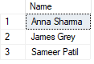

Display customer details who has fax number





Dsiplay customer details whose name holds second letter u





Select order details where unit price is greater than 10 and less than 20





Display order details which contain shipping date and arrange order by date



Print the orders shipped by shipname la come dabondance between 2 dates



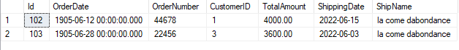

Print the products supplied by exotic liquids



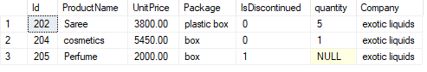

Print avg quantity order for every product



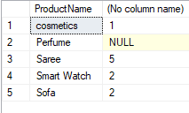

Print all shipping company names and ship names if they are operational



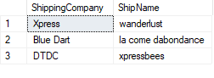

Print all employee with manager name



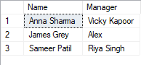

Print bill for given order id bill should contain ProductNAme, CategoryName, price after discount





Print the total price of orders which have the products supplied by exotic liquids if the price is > 50 and also print it by shipping Company name

select product.Company, product.[UnitPrice] as TotalPrice, orders.[ShippingCompany] from product inner join orders on orders.[ShipName]=product.[ShipName] where product.Company='exotic liquids' and product.UnitPrice>50

